Interface in Java

An **interface in java** is a blueprint of a class. It has static constants and abstract methods.

The interface in java is **a mechanism to achieve abstraction**. There can be only abstract methods in the java interface not method body. It is used to achieve abstraction and multiple inheritance in Java.

Java Interface also **represents IS-A relationship**.

It cannot be instantiated just like abstract class.

## **Why use Java interface?**

There are mainly three reasons to use interface. They are given below.

* It is used to achieve abstraction.
* By interface, we can support the functionality of multiple inheritance.
* It can be used to achieve loose coupling.

#### **Understanding relationship between classes and interfaces**

As shown in the figure given below, a class extends another class, an interface extends another interface but a **class implements an interface**.

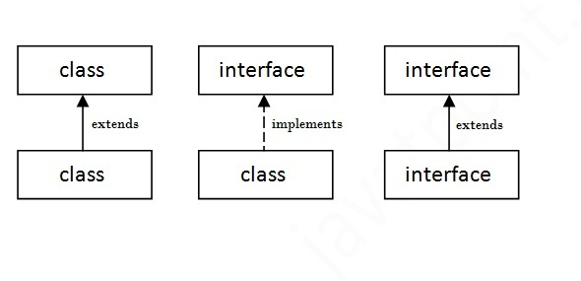

## **Java Interface Example**

In this example, Printable interface has only one method, its implementation is provided in the A class.

1. **interface** printable{
2. **void** print();
3. }
4. **class** A6 **implements** printable{
5. **public** **void** print(){System.out.println("Hello");}
7. **public** **static** **void** main(String args[]){
8. A6 obj = **new** A6();
9. obj.print();
10. }
11. }

[**Test it Now**](http://www.javatpoint.com/opr/test.jsp?filename=A6)

Output:

Hello

## **Java Interface Example: Drawable**

In this example, Drawable interface has only one method. Its implementation is provided by Rectangle and Circle classes. In real scenario, interface is defined by someone but implementation is provided by different implementation providers. And, it is used by someone else. The implementation part is hidden by the user which uses the interface.

*File: TestInterface1.java*

1. //Interface declaration: by first user
2. **interface** Drawable{
3. **void** draw();
4. }
5. //Implementation: by second user
6. **class** Rectangle **implements** Drawable{
7. **public** **void** draw(){System.out.println("drawing rectangle");}
8. }
9. **class** Circle **implements** Drawable{
10. **public** **void** draw(){System.out.println("drawing circle");}
11. }
12. //Using interface: by third user
13. **class** TestInterface1{
14. **public** **static** **void** main(String args[]){
15. Drawable d=**new** Circle();//In real scenario, object is provided by method e.g. getDrawable()
16. d.draw();
17. }}

[**Test it Now**](http://www.javatpoint.com/opr/test.jsp?filename=TestInterface1)

Output:

drawing circle

## **Java Interface Example: Bank**

Let's see another example of java interface which provides the implementation of Bank interface.

*File: TestInterface2.java*

1. **interface** Bank{
2. **float** rateOfInterest();
3. }
4. **class** SBI **implements** Bank{
5. **public** **float** rateOfInterest(){**return** 9.15f;}
6. }
7. **class** PNB **implements** Bank{
8. **public** **float** rateOfInterest(){**return** 9.7f;}
9. }
10. **class** TestInterface2{
11. **public** **static** **void** main(String[] args){
12. Bank b=**new** SBI();
13. System.out.println("ROI: "+b.rateOfInterest());
14. }}

[**Test it Now**](http://www.javatpoint.com/opr/test.jsp?filename=TestInterface2)

Output:

ROI: 9.15

## **Multiple inheritance in Java by interface**

If a class implements multiple interfaces, or an interface extends multiple interfaces i.e. known as multiple inheritance.

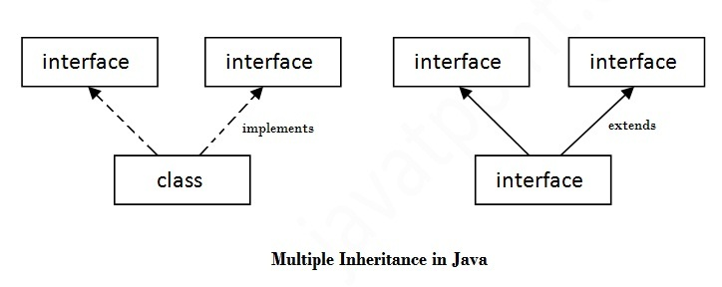

1. **interface** Printable{
2. **void** print();
3. }
4. **interface** Showable{
5. **void** show();
6. }
7. **class** A7 **implements** Printable,Showable{
8. **public** **void** print(){System.out.println("Hello");}
9. **public** **void** show(){System.out.println("Welcome");}
11. **public** **static** **void** main(String args[]){
12. A7 obj = **new** A7();
13. obj.print();
14. obj.show();
15. }
16. }

[**Test it Now**](http://www.javatpoint.com/opr/test.jsp?filename=A7)

Output:Hello

Welcome

## **Q) Multiple inheritance is not supported through class in java but it is possible by interface, why?**

As we have explained in the inheritance chapter, multiple inheritance is not supported in case of class because of ambiguity. But it is supported in case of interface because there is no ambiguity as implementation is provided by the implementation class. For example:

1. **interface** Printable{
2. **void** print();
3. }
4. **interface** Showable{
5. **void** print();
6. }
8. **class** TestTnterface3 **implements** Printable, Showable{
9. **public** **void** print(){System.out.println("Hello");}
10. **public** **static** **void** main(String args[]){
11. TestTnterface1 obj = **new** TestTnterface1();
12. obj.print();
13. }
14. }

[**Test it Now**](http://www.javatpoint.com/opr/test.jsp?filename=testInterface3)

Output:

Hello

As you can see in the above example, Printable and Showable interface have same methods but its implementation is provided by class TestTnterface1, so there is no ambiguity.

## **Interface inheritance**

A class implements interface but one interface extends another interface .

1. **interface** Printable{
2. **void** print();
3. }
4. **interface** Showable **extends** Printable{
5. **void** show();
6. }
7. **class** TestInterface4 **implements** Showable{
8. **public** **void** print(){System.out.println("Hello");}
9. **public** **void** show(){System.out.println("Welcome");}
11. **public** **static** **void** main(String args[]){
12. TestInterface4 obj = **new** TestInterface4();
13. obj.print();
14. obj.show();
15. }
16. }

[**Test it Now**](http://www.javatpoint.com/opr/test.jsp?filename=TestInterface4)

Output:

Hello

Welcome

## **Java 8 Default Method in Interface**

Since Java 8, we can have method body in interface. But we need to make it default method. Let's see an example:

*File: TestInterfaceDefault.java*

1. **interface** Drawable{
2. **void** draw();
3. **default** **void** msg(){System.out.println("default method");}
4. }
5. **class** Rectangle **implements** Drawable{
6. **public** **void** draw(){System.out.println("drawing rectangle");}
7. }
8. **class** TestInterfaceDefault{
9. **public** **static** **void** main(String args[]){
10. Drawable d=**new** Rectangle();
11. d.draw();
12. d.msg();
13. }}

[**Test it Now**](http://www.javatpoint.com/opr/test.jsp?filename=TestInterfaceDefault)

Output:

drawing rectangle

default method

## **Java 8 Static Method in Interface**

Since Java 8, we can have static method in interface. Let's see an example:

*File: TestInterfaceStatic.java*

1. **interface** Drawable{
2. **void** draw();
3. **static** **int** cube(**int** x){**return** x*x*x;}
4. }
5. **class** Rectangle **implements** Drawable{
6. **public** **void** draw(){System.out.println("drawing rectangle");}
7. }
9. **class** TestInterfaceStatic{
10. **public** **static** **void** main(String args[]){
11. Drawable d=**new** Rectangle();
12. d.draw();
13. System.out.println(Drawable.cube(3));
14. }}

[**Test it Now**](http://www.javatpoint.com/opr/test.jsp?filename=TestInterfaceStatic)

Output:

drawing rectangle

27

## **Q) What is marker or tagged interface?**

An interface that have no member is known as marker or tagged interface. For example: Serializable, Cloneable, Remote etc. They are used to provide some essential information to the JVM so that JVM may perform some useful operation.

1. //How Serializable interface is written?
2. **public** **interface** Serializable{
3. }

#### **Nested Interface in Java**

Note: An interface can have another interface i.e. known as nested interface. We will learn it in detail in the nested classes chapter. For example:

1. **interface** printable{
2. **void** print();
3. **interface** MessagePrintable{
4. **void** msg();
5. }
6. }

# Java Nested Interface

An interface i.e. declared within another interface or class is known as nested interface. The nested interfaces are used to group related interfaces so that they can be easy to maintain. The nested interface must be referred by the outer interface or class. It can't be accessed directly.

### **Points to remember for nested interfaces**

There are given some points that should be remembered by the java programmer.

* Nested interface must be public if it is declared inside the interface but it can have any access modifier if declared within the class.
* Nested interfaces are declared static implicitely.

### **Syntax of nested interface which is declared within the interface**

1. **interface** interface_name{
2. ...
3. **interface** nested_interface_name{
4. ...
5. }
6. }

### **Syntax of nested interface which is declared within the class**

1. **class** class_name{
2. ...
3. **interface** nested_interface_name{
4. ...
5. }
6. }

### **Example of nested interface which is declared within the interface**

|  |
| --- |
| In this example, we are going to learn how to declare the nested interface and how we can access it. |

1. **interface** Showable{
2. **void** show();
3. **interface** Message{
4. **void** msg();
5. }
6. }
7. **class** TestNestedInterface1 **implements** Showable.Message{
8. **public** **void** msg(){System.out.println("Hello nested interface");}
10. **public** **static** **void** main(String args[]){
11. Showable.Message message=**new** TestNestedInterface1();//upcasting here
12. message.msg();
13. }
14. }

|  |
| --- |
| As you can see in the above example, we are acessing the Message interface by its outer interface Showable because it cannot be accessed directly. It is just like almirah inside the room, we cannot access the almirah directly because we must enter the room first. In collection frameword, sun microsystem has provided a nested interface Entry. Entry is the subinterface of Map i.e. accessed by Map.Entry. |

### **Internal code generated by the java compiler for nested interface Message**

|  |
| --- |
| The java compiler internally creates public and static interface as displayed below:. |

1. **public** **static** **interface** Showable$Message
2. {
3. **public** **abstract** **void** msg();
4. }

### **Example of nested interface which is declared within the class**

|  |
| --- |
| Let's see how can we define an interface inside the class and how can we access it. |

1. **class** A{
2. **interface** Message{
3. **void** msg();
4. }
5. }
7. **class** TestNestedInterface2 **implements** A.Message{
8. **public** **void** msg(){System.out.println("Hello nested interface");}
10. **public** **static** **void** main(String args[]){
11. A.Message message=**new** TestNestedInterface2();//upcasting here
12. message.msg();
13. }
14. }

### **Can we define a class inside the interface?**

Yes, If we define a class inside the interface, java compiler creates a static nested class. Let's see how can we define a class within the interface:

1. **interface** M{
2. **class** A{}
3. }